Steps to refresh Rightmove Connections in Sandboxes
To configure the Rightmove settings to connect to the test site rather than the live site

1. Update Custom Metadata
- Rightmove_Certificate_Name = Rightmove_API_Test
- Rightmove_API_removeProperty = https://adfapi.adftest.rightmove.com/v1/property/removeproperty
- Rightmove_API_sendProperty = https://adfapi.adftest.rightmove.com/v1/property/sendpropertydetails
- Rightmove_Site_URL = https://www.adftest.rightmove.com/properties/

2. Update Named Credentials
GraingerApi_MediaAssets
- Check screenshots in 'SIT Sandbox Refresh.xlsx'
URL = https://3pqf78sc55.execute-api.eu-west-2.amazonaws.com/prod

3. Email Rightmove ADF team and provide org id
adfsupport@rightmove.co.uk
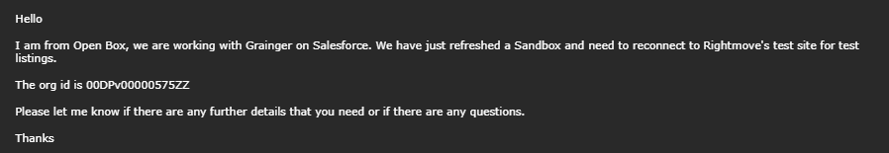
They will respond to confirm a listing has been posted successfully to the test site

